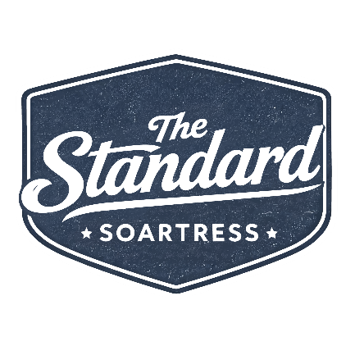

Our Associates

Hire the “Smile”
- Hire associates who enjoy serving people and making them smile as a natural instinct.

Onboard with a Purpose
- Be methodical and relentless in demanding a second-to-none onboarding process for all associates.

Be Respectful of Associates
- Review all team members on time, respond to associates’ requests within 48 business hours, and provide honest, direct, and timely feedback when necessary.

Celebrate
- Find small reasons to thank and celebrate with each associate you interact with daily.

Our Customers

Greet Within 10 Feet
- All guests must be acknowledged within 10 feet of an associate.

Same-Day Response
- All guests, physical or virtual, who reach out with an inquiry must receive a same-day response, even if the response is simply an acknowledgment that we received their inquiry along with a timeline for answering their request.

Guest-Focused Staffing
- Always have the right people on staff, at the right time, with the right supplies and training to provide amazing customer service. Anticipate a guest’s needs before they realize they have them, and always look at each area of the hotel daily through a guest’s lens.

The River Is Always Deeper Than One Reviewer
- Online review responses should not target the reviewer, but rather focus on how the response will be viewed by potential customers who have not yet decided to stay with you. Do you sound reasonable and caring, or defensive and dismissive? This will directly influence where they choose to stay.
- Always respond to 100% of the reviews, including those that say great things about you. Reviews should be responded to by the GM or, in larger hotels, a senior leader. Titles count to the viewer.

Guest Pulse Check
- Check in with every guest at least once during their stay. This can be done through text or a phone call.

Our Communication

Sales and Operations Daily Standups
- Communication is the lifeblood of any organization and will directly determine its success. Daily standups should be consistent, quick, focused, meaningful, and purposeful.

Impactful Meetings
- Respect everyone’s time, along with your own. Meetings should have a purpose, an agenda, and a clear action steps at conclusion. Attendees should be on time, present, and attentive. No side work. Only have the people in the meeting who are critical to moving the agenda forward. Everyone’s time is important, so if someone doesn’t need to be there, don’t make them attend.

Be a Journalist
- Journalists have deadlines, develop inquisitive questions as to why, report facts, and present information to their target reader. Our expectations are no different. Hit your deadlines, dig deep into why, report facts, and answer the anticipated questions of your target reader. This could be you in the future, the property team, the corporate team, investors, bankers, auditors, or government agencies.

Stand on the Soapbox
- If you have an issue with your asset that could impact results—storms, power outages, associate injuries, staffing challenges, system outages, or out-of-order rooms for more than a day, just to mention a few—you must notify corporate leadership and continue to do so until the issue is resolved.

Execute Effectively

Be the Brand
- You represent SOARTRESS to the brand. You must create incredible plans, measure consistently, anticipate curveballs, and motivate the team to be in the TOP 30% of the brand in all categories. This includes guest service scores, audit scores, guest communication, training, and any other brand-focused measurement.

Avoid Attending the Circus
- Make decisions based on facts, data, and the desired outcome while anticipating challenges and obstacles. Don’t make decisions based heavily on emotions. Use the 1-3-1 to help with this. This applies to associates, guests, vendors, systems, the brand, and all other stakeholders.

Great Systems Win
- Make sure your support systems are always regularly tested and that scheduled preventive maintenance is documented to ensure they are ready when you need them. This includes, but is not limited to, tech stack, HVAC, elevators, generators, boilers, backup batteries, and other key systems.

Be Disruptive
- What are you doing differently from your competitive set to stand out in the marketplace? If you do not have at least three items, you are not being disruptive. You need at least one product, one service, and one sales item.

Everyone Is a Salesperson
- Is a lead-catcher program in place at the front desk? Does the team know which VIPs are arriving today? Does the GM meet with our top accounts several times a year in their offices?

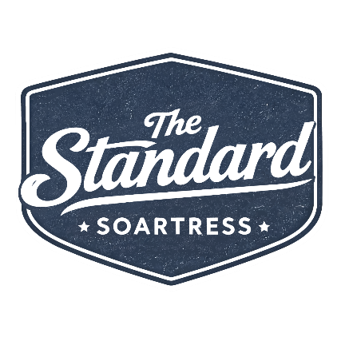

Our Associates
Hire the “Smile”
Onboard with a Purpose
Be Respectful of Associates
Celebrate

Our Customers
Greet Within 10 Feet
Same-Day Response
Guest-Focused Staffing
The River Is Always Deeper Than One Reviewer
Guest Pulse Check

Our Communication
Sales and Operations Daily Standups
Impactful Meetings
Be a Journalist
Stand on the Soapbox

Execute Effectively
Be the Brand
Avoid Attending the Circus
Great Systems Win
Be Distributive
Everyone Is a Salesperson

